One product add into the cart the pop up should come like this given image below:-  
  
  
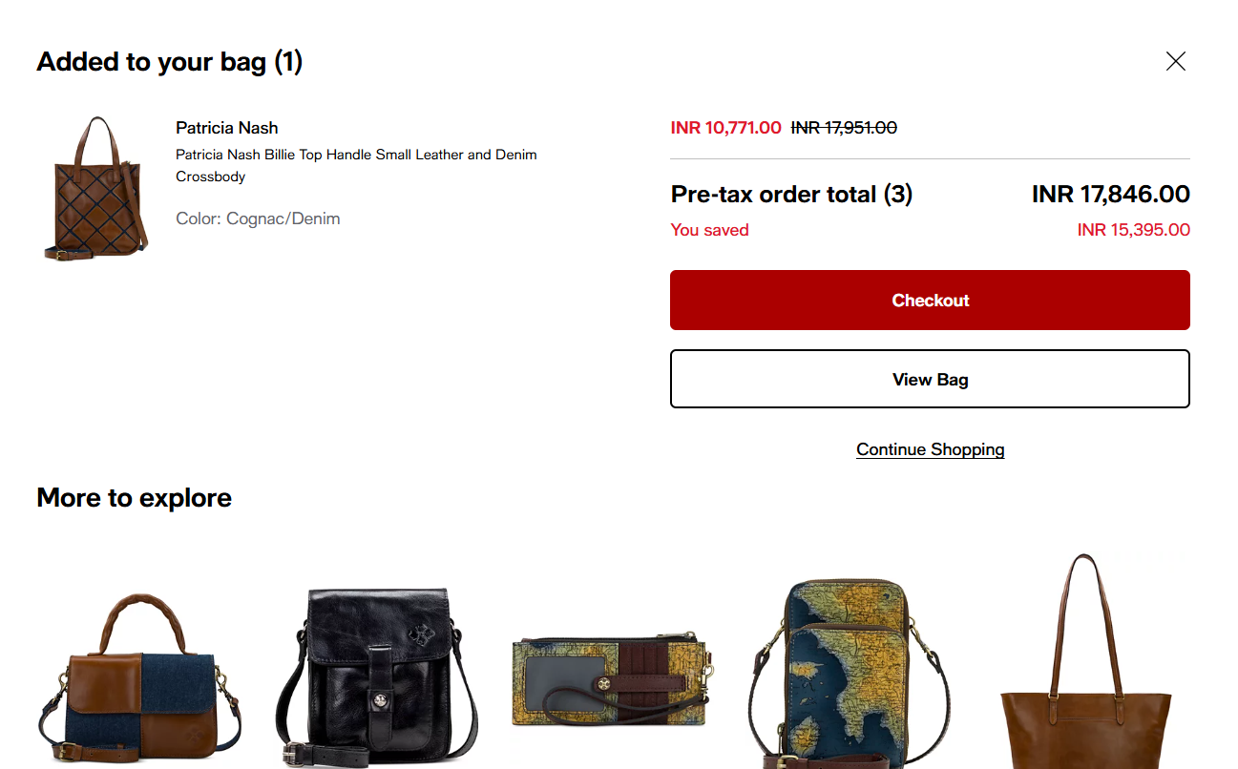  
  
  
  
  
Adding the product in cart it should be look like this given image below:-  
  
  
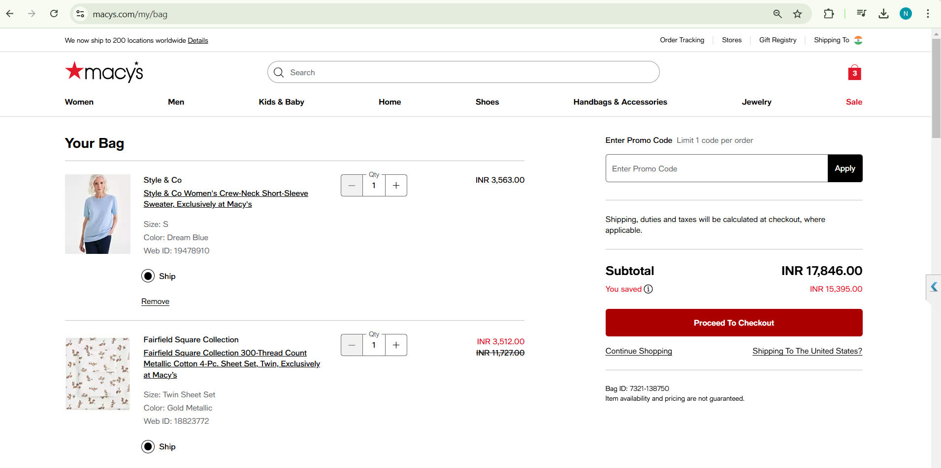  
  
After checkout the cart the image should come like this:-  
  
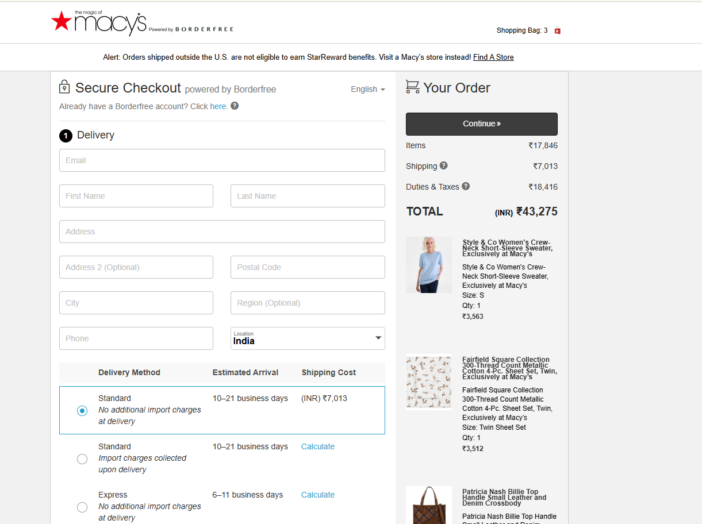  
  
  
Placing the order final image need to be show like this:-  
  
  
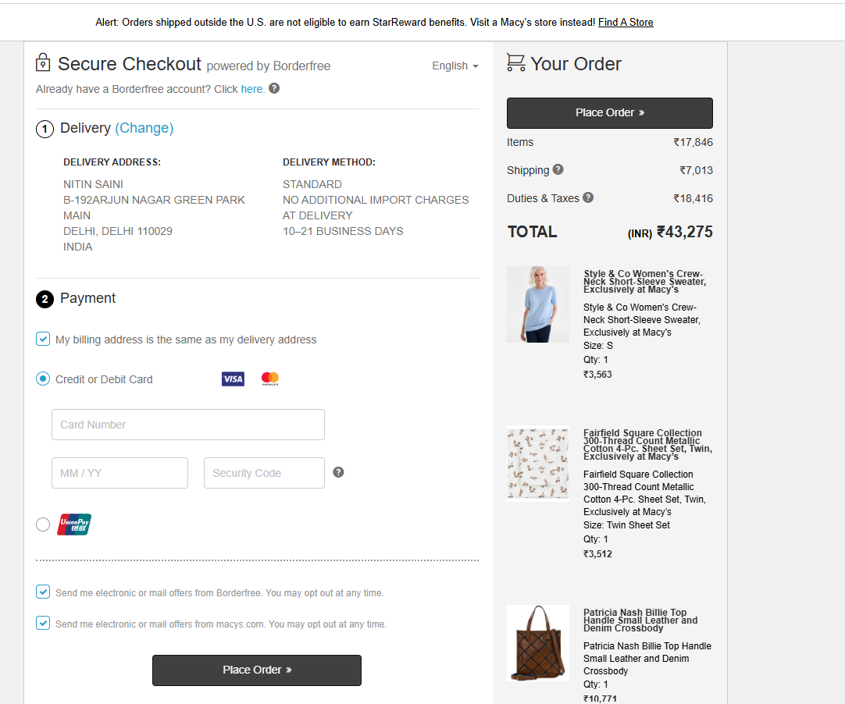  
  
  
History of order check this image need to be display:-  
  
  
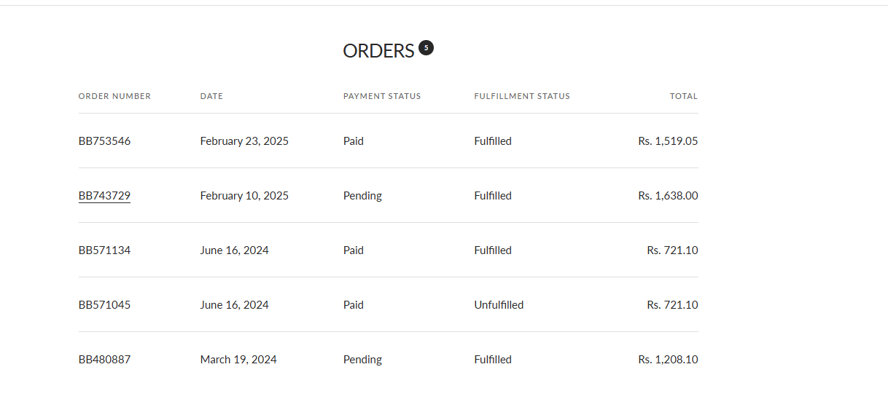  
  
After clicking the order this image needs to come:-  
  
